**Chemistry Laboratory**

1. **Determination of the amount of sodium Carbonate and sodium hydroxide in a mixture by titration**

|  |  |  |  |
| --- | --- | --- | --- |
|  | **Titration I** | **Titration II** | **Titration III** |
| Burette solution | HCl (N/50) | HCl (N/50) |  |
| Pipette solution | Std. NaOH (20ml) | Sample water (50ml ) | Sample water (50ml ) |
| Indicator | Phenolphthalein | Phenolphthalein | Methyl orange |
| End point | Pink to colourless | Pink to colourless | Yellow to red orange |
| Equivalent weight of Na2CO3 – 53  Equivalent weight of NaOH - 40 | | | |

1. **Determination of Hardness (Ca2+) of water using EDTA – Complexometry method**

|  |  |  |  |
| --- | --- | --- | --- |
|  | **Titration I** | **Titration II** | **Titration III** |
| Burette solution | EDTA | EDTA | EDTA |
| Pipette solution | Std. Hard water (20ml) | Sample Hard water (20ml) | Boiled water (20ml) |
| Indicator | 2drops of Eriochrome black-T (EBT) | 2drops of Eriochrome black-T (EBT) | 2drops of Eriochrome black-T (EBT) |
| Additional solution | 5ml of Ammonia buffer | 5ml of Ammonia buffer | 5ml of Ammonia buffer |
| End point | Colour change from wine red to steel blue | Colour change from wine red to steel blue | Colour change from wine red to steel blue |
| Equivalent weight of CaCO3 - 50 | | |  |

1. **Estimation of amount of chloride content of a water sample.**

|  |  |  |
| --- | --- | --- |
|  | **Titration I** | **Titration II** |
| Burette solution | Silver Nitrate (AgNO3) | Silver Nitrate (AgNO3) |
| Pipette solution | Std. Sodium Chloride (20ml) | Sample water (20ml ) |
| Indicator | Potassium Chromate (1ml) | Potassium Chromate (1ml) |
| End point | Yellow colour to reddish brown colour | Yellow colour to reddish brown colour |
| Equivalent weight of chloride ion : 35. 35 | | |

1. **Determination of strength of an Acid using pH meter**

**Apparatus Required**

pH meter, Electrode, Beaker, Pipette, Burette

**Chemical required**

Hydrochloric acid (HCl), Sodium Hydroxide (NaOH), Buffer of pH = 4 and 9.2.

**Model Graph**

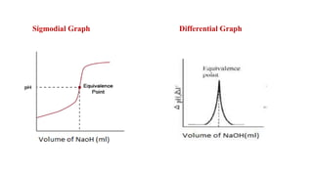

**Procedure**

Beaker Solution : 20ml of HCl + 20ml of Distilled water + Glass rod

Burette Solution : NaOH

Electrode : Glass Electrode

1. **Determination of strength of an Acid by Conductometry**

**Apparatus Required Model Graph**

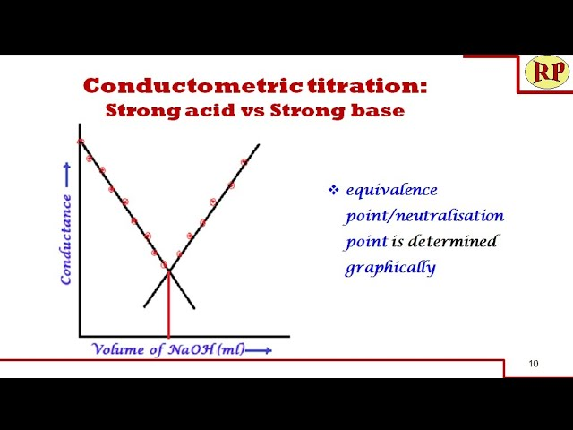Glass rod, Beaker, Pipette, Burette,

**Conductivity cell**

**Chemical required**

Hydrochloric acid (HCl), Sodium Hydroxide (NaOH), Distilled water

**Procedure**

Beaker Solution : 20ml of HCl + 20ml of Distilled water + Glass rod

Burette Solution : NaOH

Cell : Conductivity cell

1. **Determination of strength of an Mixture of acetic Acid and Hydrochloric acid by Conductometry**

**Apparatus Required Model Graph**

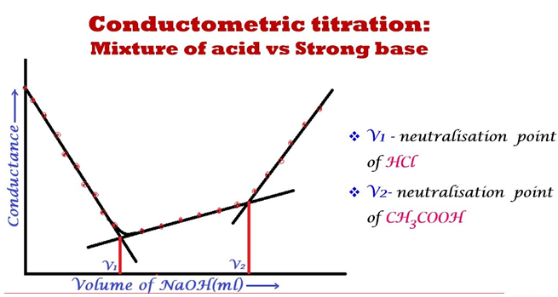 Glass rod, Beaker, Pipette, Burette, Conductivity cell

**Chemical required**

Acetic acid and Hydrochloric acid, Sodium Hydroxide (NaOH), Distilled water

**Procedure**

Beaker Solution : 20ml of Mixture of acid + 20ml of Distilled water + Glass rod

Burette Solution : NaOH

Cell : Conductivity cell

1. **Determination of Ferrous ion using potassium dichromate ny Potentiometric titration**

**Apparatus Required**

Glass rod, Beaker, Pipette, Burette, Calomel electrode, Platinum electrode

**Chemical required**

Ferrous ammonium Sulfate (FAS), Sulfuric acid (H2SO4), and Potassium permanganate (KMnO4) Distilled water

**Model Graph**

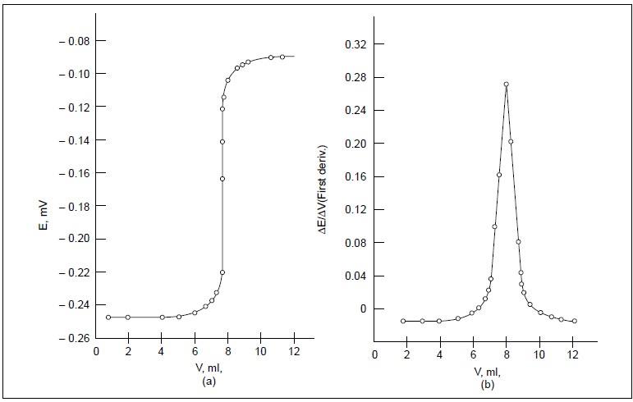

**Procedure**

Beaker Solution : 20ml of FAS + 20ml of dilute sulfuric acid

Burette Solution : KMnO4

Electrode : Calomel electrode + Platinum electrode